Ideation Phase

Define the Problem Statements

|  |  |
| --- | --- |
| Date | 29 April 2023 |
| Team ID | Au513220106312 |
| Project Name | AI enabled car parking using open CV |
| Maximum Marks | 2 Marks |

# Customer Problem Statement Template:

Create a problem statement to understand your customer's point of view. The Customer Problem Statement template helps you focus on what matters to create experiences people will love.

A well-articulated customer problem statement allows you and your team to find the ideal solution for the challenges your customers face. Throughout the process, you’ll also be able to empathize with your customers, which helps you better understand how they perceive your product or service.

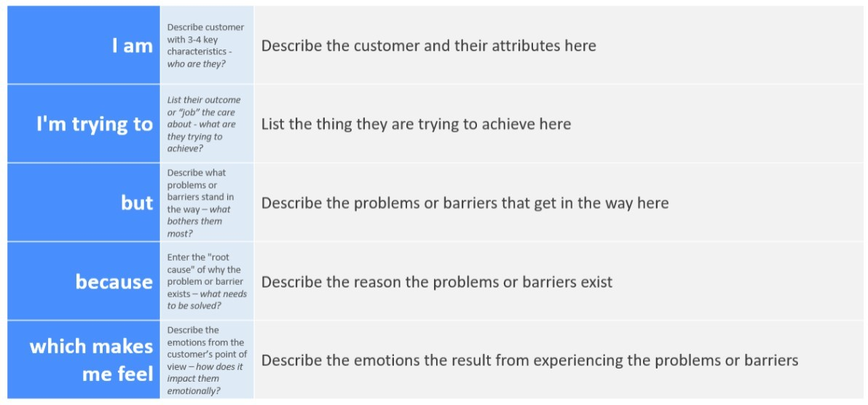

Reference: https://miro.com/welcomeonboard/VzEwbnBicHk2S0JJbkhtZk1kRVhKc0RpSGlld2VtMVJXM3 Fld0RoM1Y0dTU3Y2tBeDg1b0NPZEdSUDhlYXZXTnwzNDU4NzY0NTUzMjA4NDgwNTM3fDI=?

share_link_id=605333897439

# Example:

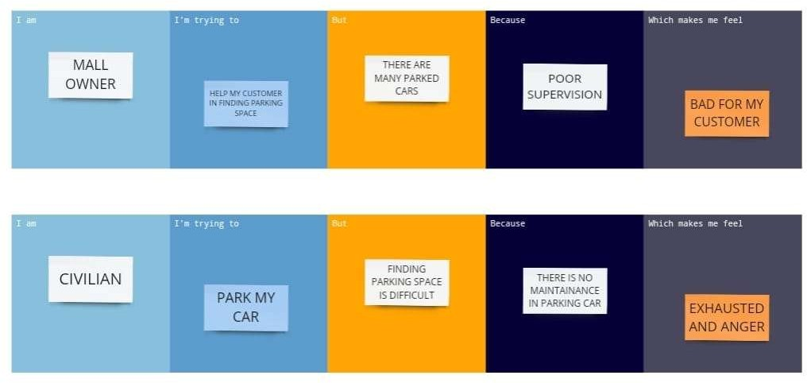

|  |  |  |  |  |  |
| --- | --- | --- | --- | --- | --- |
| **Problem**  **Statement (PS)** | **I am**  **(Customer)** | **I’m trying to** | **But** | **Because** | **Which makes me feel** |
| PS-1 |  |  |  |  |  |
| PS-2 |  |  |  |  |  |